|  |  |
| --- | --- |
|  | **Date- 08/02/2023** |
| **Procedure for Replacement of DPM PCB** | |

**Model: THYROLUXE-600**

**Reason for Replacement**: To show **Set current** and actual current on DPM PCB

**Steps for Replacement:**

1. Remove the existing DPM PCB from the machine carefully by removing Screws provided, as shown in figure below.

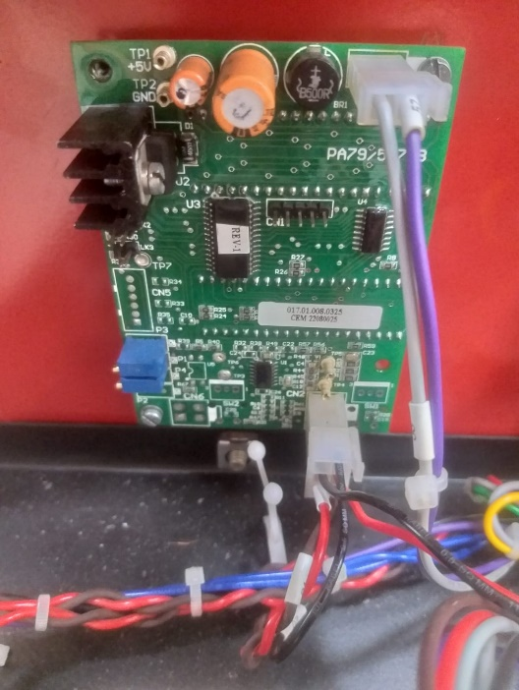

**Screw**

Fig. Existing PA79/557/B DPM PCB

1. Take the New PCB (PA79/557/B) REV-2 as seen in figure 2a, verify that the PCB has the item code as **017.01.008.0372** (Fig b) and assemble it.

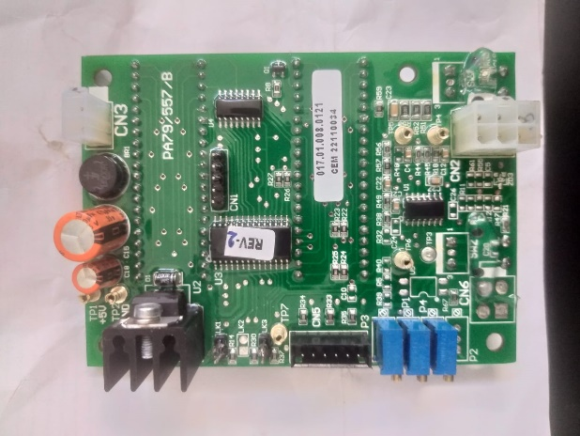

017.01.008.0372

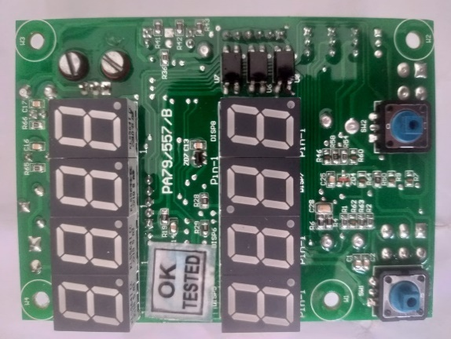

**Fig b. Back View**

**Fig a. Front View**

**Wiring Modification**:

1. 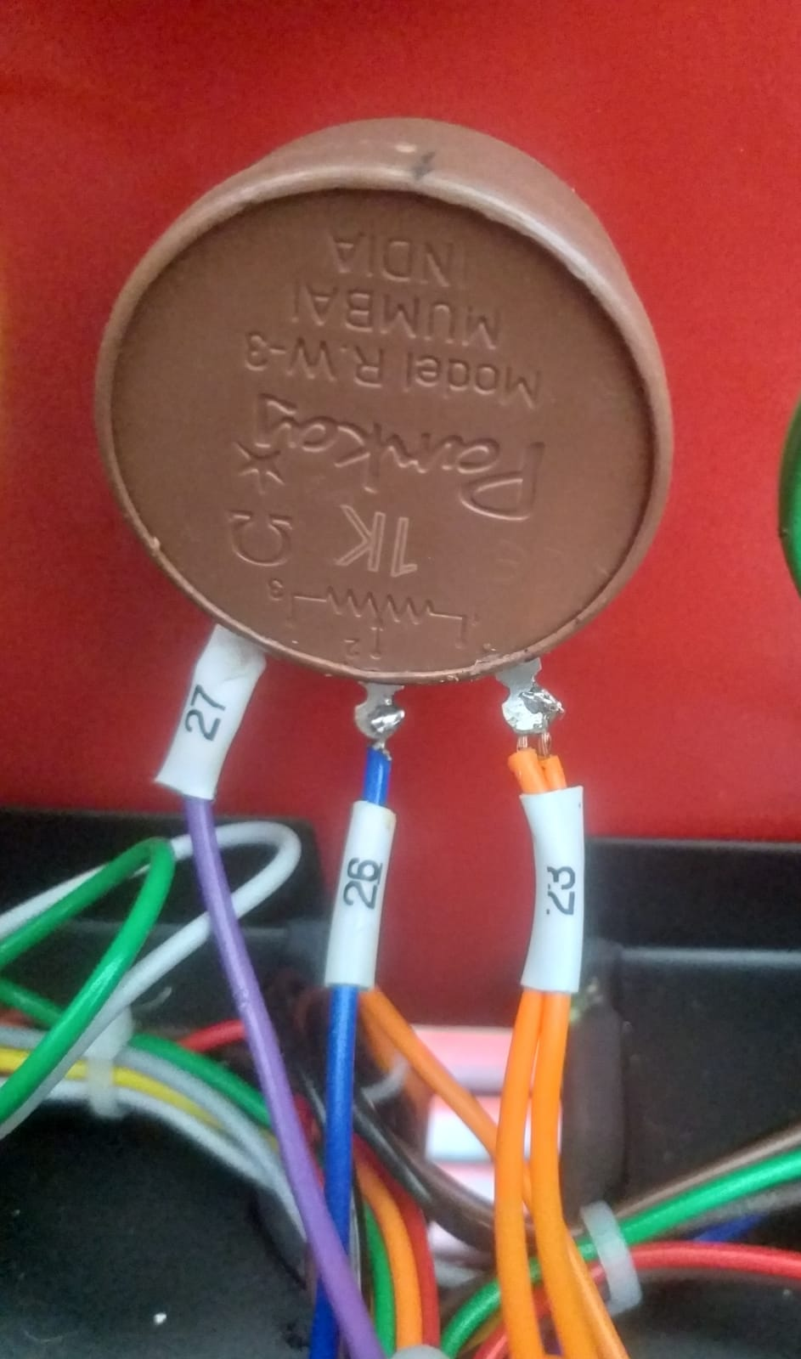You can see the Current pot (Ref. Figure below), with connections as shown, where wire 23 is Ground while 26 is Reference wire.

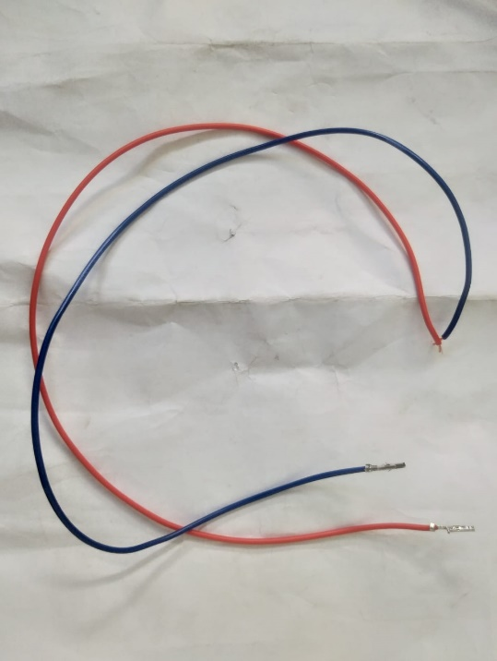

1. You are provided with the extra connecting wires viz. blue and orange wire.
2. Solder the blue wire at the wire no.26 while orange wire at wire no.23 as you can see in figure below,

**Fig. Current Pot after modified Connection.**

1. Connect the Blue and Orange wires at **Pin 5** and **Pin 2** of **Connector CN2** respectively as shown in figure.

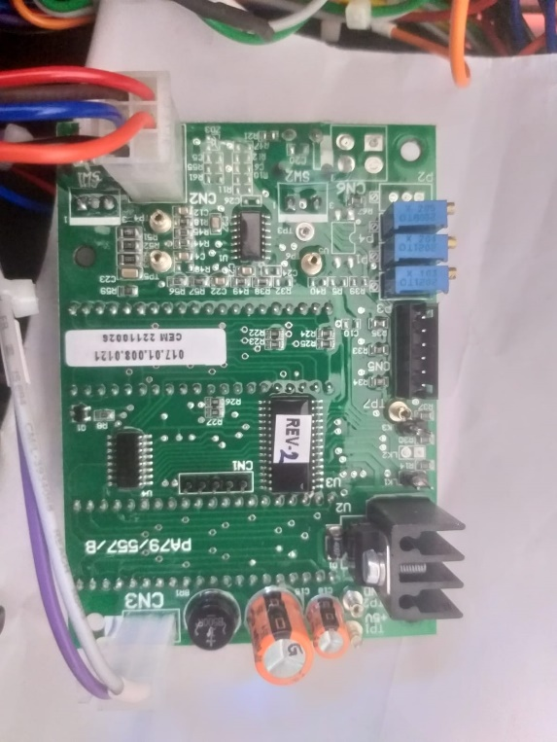

Orange wire (23) from Set Current

Blue wire (26) from Set Current Pot

017.01.008.0372

Pot CN2

23-🡪 Pin 2

26-🡪 Pin 5



**Set current Pot to CN2 connector Connection diagram.**

**Notes:**

1. 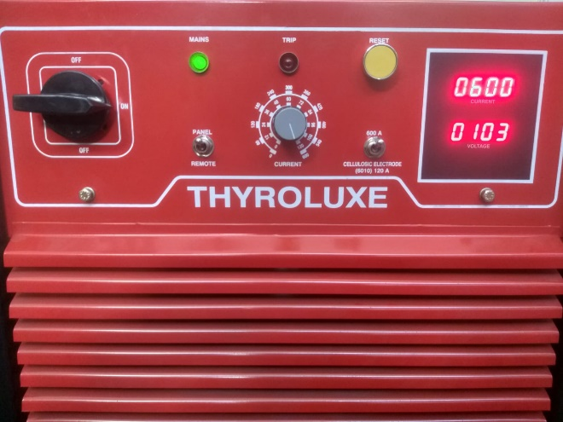After all the modification switch on the machine. Set the pot at minimum position. At this position, display will show 10A. Now vary the set current pot to maximum position. At this position, display will show 600A (ref. Image below).

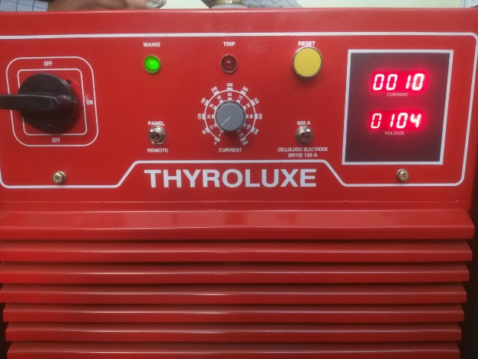

**DPM showing 600 at Maximum and 10 at Minimum set current pot position.**

1. If the display is not showing 600 at max, Measure the Voltage between TP6 and GND as shown below,

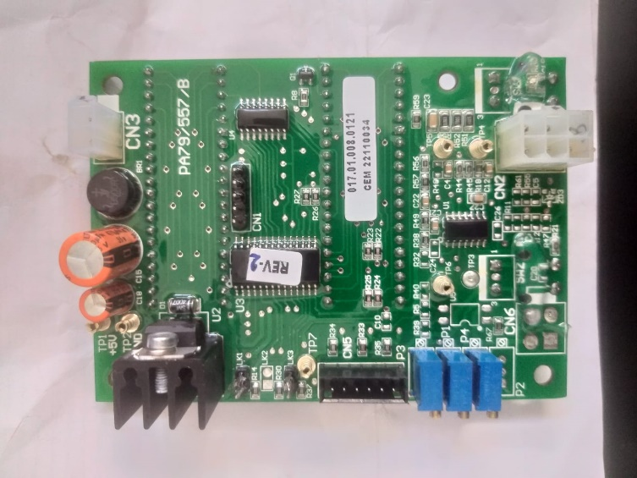

**TP6**

**GND**

**P4**

017.01.008.0372

1. The voltage should be approximately **3 V** and display should display **600 A**. If the voltage is different, **adjust the P4 pot** to get 3 V or to get 600A at display. (Ref. image)
2. After this adjustment the DPM should show 10A-600A, for Minimum to Maximum set current pot position respectively.
3. When the switch is at **cellulose electrode** position it will show **118A** at maximum position of set current pot.

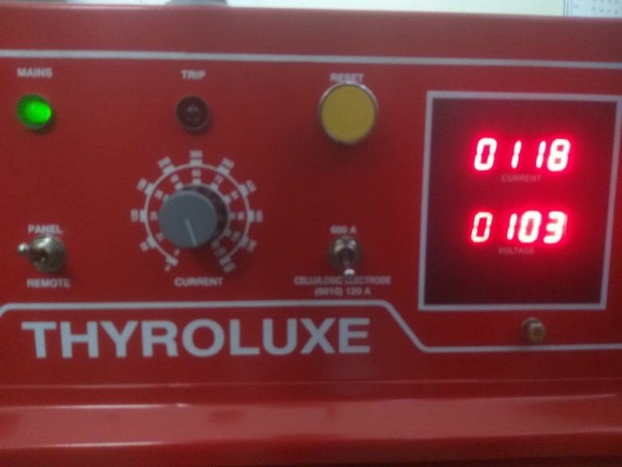

**When the switch is at Cellulose Electrode Display shows 118A.**

Prepared By, Checked By, Approved By,

Mr. Rahul Raut (TDC-E) Mr. Jeetendra Kadam (TDC-E) Mr. Sachin Dobhada (TDC-E)